S1000D - an international specification for technical information
S1000D is an international specification for procurement and production of technical information. It specifies how technical information and documentation should be managed by supporting:
- Planning
- Management
- Production
- Exchange
- Review
- Publication
Technical information produced according to S1000D is created as data modules in XML (Extensible Markup Language) and stored in a data base, CSDB (common source data base). llustrations, graphics and other information related to the technical information are also stored in the database.
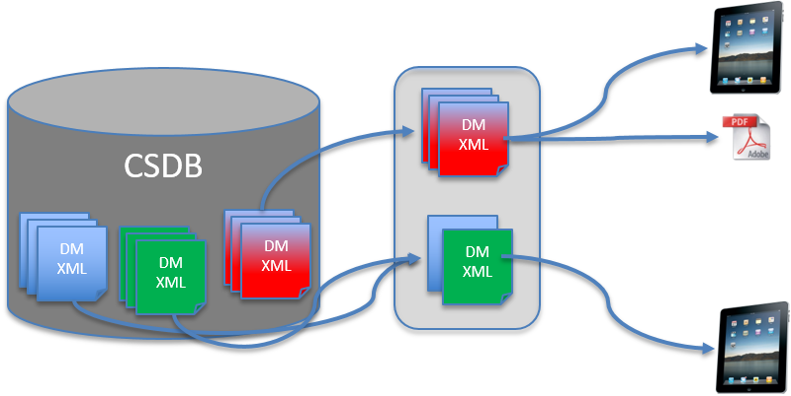
A data module (DM) is the smallest information carrying part in a technical publication. It is unique and can be reused in several publications. A data module code is used to identify a data module. The data module code tells us:
- What product it belongs to
- Where it fits in the product structure
- What kind of information it carries
- What status it has and other kinds of information.
At publication the data modules associated to each other are collected into one or more publication module(s) and published in a suitable format. S1000D supports several formats, from print to digital presentation as in a viewer, an Interactive Electronic Technical Publication (IETP).
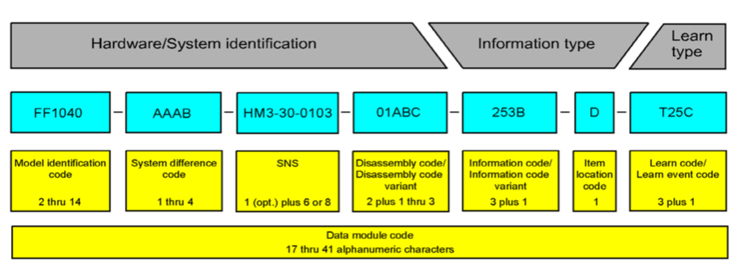

What applies at FMV?
FMV uses version 4.1 of S1000D Business Rules. In addition to S1000D 4.1, FMV also uses DIG Business Rules 1.0, Business area specific BR and project specific BR. The supplier of the technical information may also use its specific Industry Business Rules, provided that these do not conflict with the FMV Business Rules.
Business Rules is used in a layered model where S1000D 4.1 is the core while the other Business Rules adapt and supplement the rules to the needs of the procurement project without violating the S1000D 4.1.
Business area specific BR at FMV today:
- FMV Business Rules for Marine Equipment
Project specific BR at FMV today:
- Business Rules STRB90
- Business Rules STRF90
- Business Rules Leo (based on S1000D Issue 2.3)

More support at FMV
To use S1000D the procurement projects need to do some preparations. A number of decisions need to be done how to use the S1000D in various ways. These decisions constitute the project’s Business Rules. The procurement projects also need to have a clear picture of the product structure and the need of information about the technical system or product they intend to buy. As a support for the S1000D process the following documents and tools are available at FMV:
Business Rules Decision Points  (BRDP) | A list of all the decision points in the S1000D-specification. By going through the list and taking decisions the procurement project decides what kind of information that is going to be produced and to manage it.
Information code list | A list with all the information codes needed for production of data modules. The list also includes the denominations for each information code in Swedish and English. This information is very important for the technical information supplier.
Project decision points | This is a cross-reference list that presents the connection between the Business rules Decision Points (BRDP) and FMV BR, to facilitate the development of project-specific BR.
BREX checker | The BREX checker is used to control that the structure and content is correct when delivering S1000D files. Also the FMV requirements set on the delivery need to be controlled so that they comply. The checker transforms the BREX-data modules to XSLT-files to validate the files produced for technical information. Contact ilsstod@fmv.se to get the FMV’s BREX, the BREX checker tool and instructions.
IPD2PMF | The converter IPD2PMF is used when delivering IPD-files. IPD-files are illustrated parts data in S1000D-format. The IPD-files are converted into PMF, a tool for equipment lists at FMV. The converter reads the IPD-files, its content and meta data, and matches them against the PMF data set. To get access to the IPD2PMF-tool, instructions and support, contact ilsstod@fmv.se.

